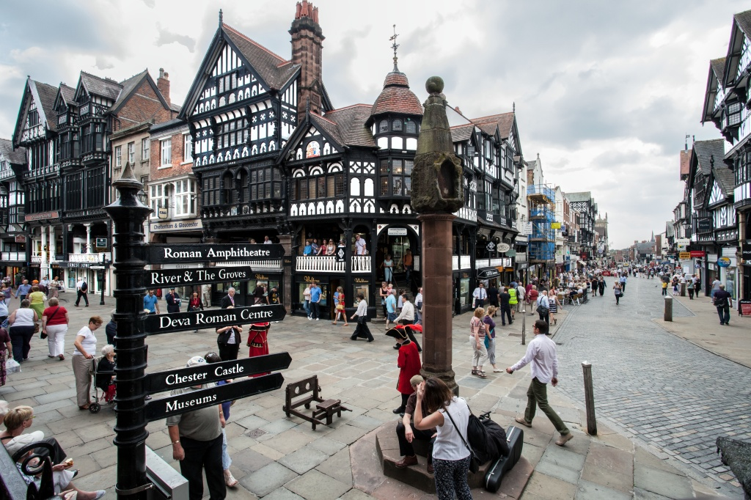
UK Language Courses

UKLC PCTO Programmes 2020-2021
(Formerly ASL – PCTO Perrcorsi per le competenze trasversali e per l’orientamento)

- Full Work Experience
- Work-Related English Lessons, Workshops & Seminars
- Work Experience & Work-Related English

UK Language Courses

Contents:

UKLC - Alternanza Scuola–Lavoro ……….…….…………………………………………………………..… Page 3

Location - Chester……………………………………………………………………………………………………...... Page 4

University of Chester – Residence………………………………………………………………………...… Page 5

University of Chester – Residence – Factsheet………………………………………………….…. Page 6

University of Chester – Homestay …….………………………………………………………………….... Page 7

University of Chester – Homestay – Factsheet……………….………………………………..…. Page 8

Location – Bristol………………………………………………………………………………………………………… Page 9

Bristol – Homestay …….………………………………………..……………………………………………….... Page 10

Bristol – Homestay – Factsheet……………………………………...………………………………..…. Page 11

Available Programmes

Full Work Experience…………………………………………..…………………………………………..…. Page 12

Work-Related English Lessons, Workshops & Seminars.…………………………………..…. Page 12

Work Experience & Work-Related English .…………………………………………………………. Page 12

Alternanza Scuola-Lavoro Price List 2019/20…………………………………………………………….. Page 13

Appendix 1 Sample Programme - Full Work Experience

Appendix 2 Sample Programme – Work-Related English Lessons, Workshops & Seminars

Appendix 3 Sample Programme - English Lessons, Work-Related Seminars, Workshops & Work Experience

“I love this school and how the staff welcome us. I'd stay here longer if I could”

- Luisa, Student - Italy
UKLC - Alternanza Scuola–Lavoro Programmes

UKLC has a proven track record of delivering a variety of unique work-based programs for Italian schools carefully designed to meet each groups’ needs. We recognize the importance of work experience and these programmes are designed to enhance the employability of Italian students.

We have worked closely with partner agencies to create programmes that satisfy the needs of students by combining:
1) Business-specific English lessons
2) Workshops, seminars, visits
3) Full work experience placements

We offer full work experience placements as part of our ASL offering. We source high quality placements within Chester, and the surrounding areas, in order to give the students the best possible experience across a number of different employment sectors.

Brief Overview

Locations
- Chester
- Bristol
Available Dates
- 1st August 2020 to 29th June 2021
Length of Stay
- 6 -28 nights
Group Size
- 10-35 students
Accommodation
- Chester Homestay – 1st August 2020 to 29th June 2021
- Chester Residence – 1st August 2020 to 29th June 2021
- Bristol Homestay – 1st August 2020 to 29th June 2021
Age Range
- 14-17 years old
Minimum Level Required According to the Common European Framework of Reference (CEFR)
- B2
Chester

The City of Chester is a vibrant mix of cafes, shops and ancient walls, rows and architectural and archaeological features. The city is home to all-year-round arts festivals, events exhibitions and street entertainment including the famous Chester races, the Rowing Regatta and the internationally acclaimed Chester Zoo.

Top Visitor Attractions From Chester
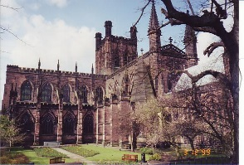
Chester Cathedral
Large Visitor Attraction of the Year Award Winner 2015.
Chester Cathedral is many things to many people: a vibrant community of worship, an ancient abbey, an archaeological treasure, a cultural hub, a centre of musical excellence and a unique blend of modern and medieval history.
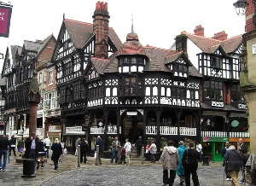

Chester Rows
The Rows are continuous half-timbered galleries reached by steps which form a second row of shops above those at street level. The rows are unique in the world to Chester and nobody is quite sure why they were built this way.

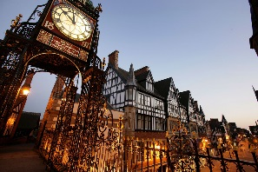
East Gate Clock
The Eastgate Clock is a turret clock built above the Eastgate of the ancient walls of Chester. The clock is considered a landmark of Chester and is the second most photographed timepiece in the United Kingdom after Big Ben.

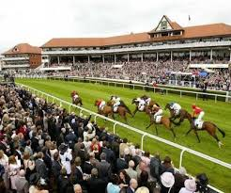
Chester Racecourse
Chester Racecourse, known as the Roodee, is according to official records the oldest racecourse still in use in England.

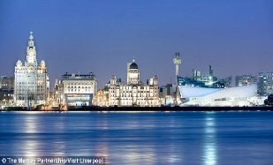
Liverpool
Liverpool is one of the UK’s most popular tourist destinations which is steeped in history. Students can visit the ever popular Beatles Story attraction and the World Museum as part of their stay.
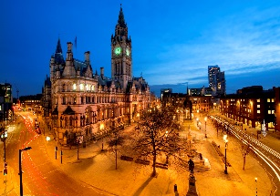

Manchester
Manchester is the northern hub of the UK and considered one of the country’s most important cities for trade. This industrial city is packed full of things to do and see including the Museum of Science & Industry (MOSI) and the National Football Museum.
University of Chester –Residence

Location
From the Roman amphitheatre and historic walls to the spectacular range of shops and coffee bars, our courses are based in the centre of it all. It is a classic, contemporary city bursting with must see treasures and 2000 years of history. Chester is a city steeped in history and character based in the north west of England within 1 hour of the popular and bustling cities of Manchester & Liverpool.

Campus
The University of Chester is a new university although having gained this status in 2005, it has a history dating back to 1839. The eclectic mix of modern and historical buildings combine to create an attractive campus set in a city that was founded as a Roman fort 2000 years ago with the name Deva Vitrix. It is now becoming a must see European destination.
The Parkgate campus of the University of Chester is set amongst beautifully kept gardens providing an abundance of green space for students whilst situated only a short walk to the centre of the historic and lively city of Chester. It is just a short walk away from the vibrant city centre with its mix of cafes, shops and ancient walls, rows, amphitheatre, historic architecture and archaeological features.
Accommodation
Residential
The residential option offers groups the chance to stay in high quality single-roomed accommodation on our exclusive Chester University Campus close to the centre of Chester, perfect for groups who would like to base themselves together in the heart of the city which boasts an eclectic mix of modern and historical buildings.

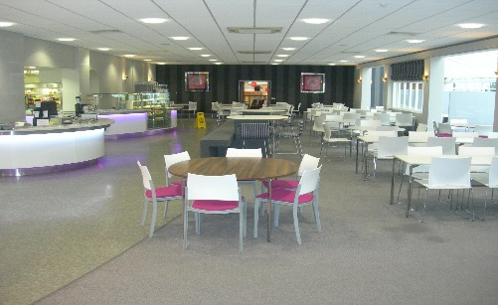
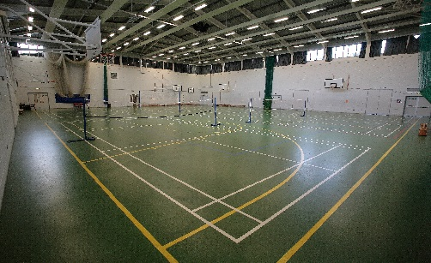
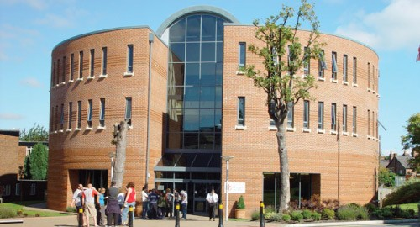

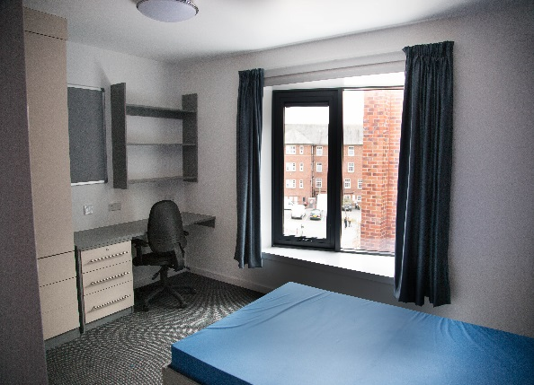
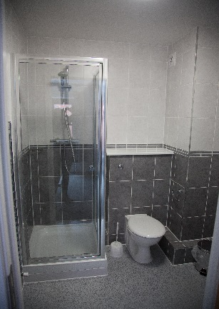
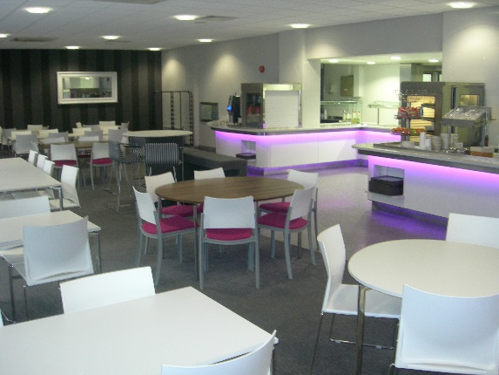

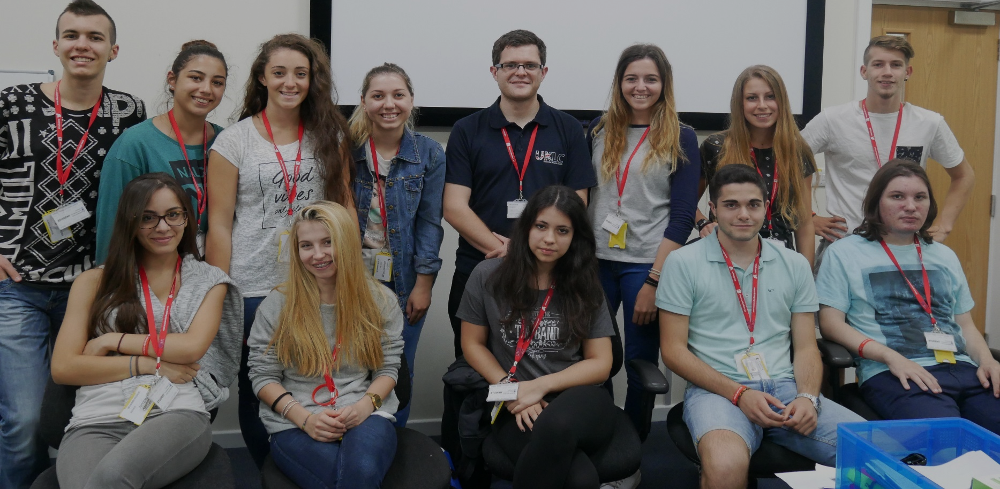
University of Chester - Residence – Factsheet

Available start dates 1st August 2020 – 29th June 2021

Accommodation Single / single en-suite

Maximum Students on site 140

Programmes Full work experience
Work-related English lessons, seminars & workshops,
Work experience & work-related English
(See Appendix for sample programmes)

Meals 3 meals a day taken in the on-site cafeteria

Nearest Airports Manchester - 35mins
Liverpool - 35mins
East Midlands - 1 hour 40mins
Birmingham - 1 hour 45mins
What’s Included:
        - Full-board residential accommodation as described
        - 30-40 certifiable of ASL hours per week (programme specific)
        - Initial grading test on arrival (programme specific)
        - Maximum classes of 16 students (programme specific)
        - End-of-course certificate and report from a British Council accredited provider

University of Chester - Homestay Accommodation

Location
From the Roman amphitheatre and historic walls to the spectacular range of shops and coffee bars, our courses are based in the centre of it all. A classic, contemporary city bursting with must see treasures and 2000 years of history, Chester is a city steeped in history and character. Based in the north west of England, it is within 40 minutes of the popular and bustling cities of Manchester & Liverpool.

Accommodation
Homestay
All of our host families are located in beautiful parts of the city. The host families have children of similar ages to students looking to take this option. We offer single and twin rooms with our accommodating and friendly families who all possess full DBS checks and are of the highest standard. Sometimes your students will be the only guest, but some homestays have two, three and occasionally four students in their house. These can be students from the same group or the same nationality or a different nationality, depending upon the requests of your students. Your students may have their own room or in some cases may end up sharing a room. All rooms are furnished with a bed and storage space and bed linen and towels are provided.

UKLC have very structured and strict policies and procedures that ensure that the students’ safety and wellbeing is paramount. UKLC will also provide a Homestay Co-Ordinator whose role it is to liaise with host families to ensure that students arrive on time and depart safely back to their homes.
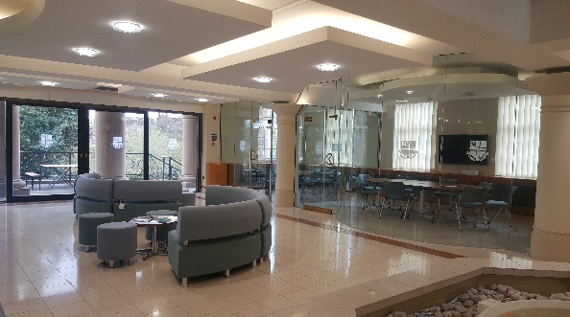
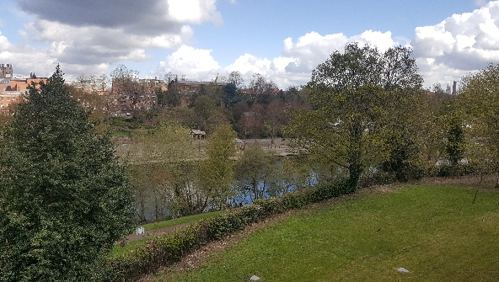
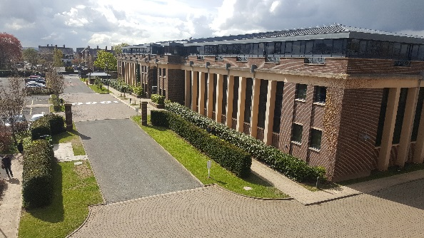
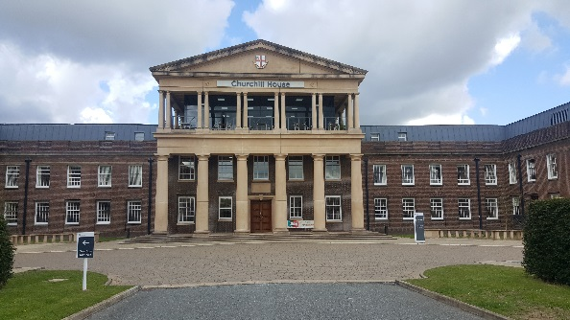
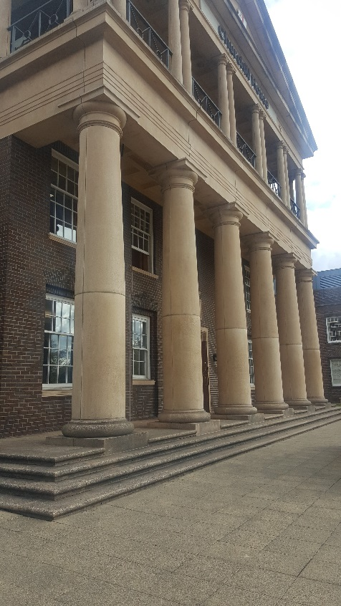

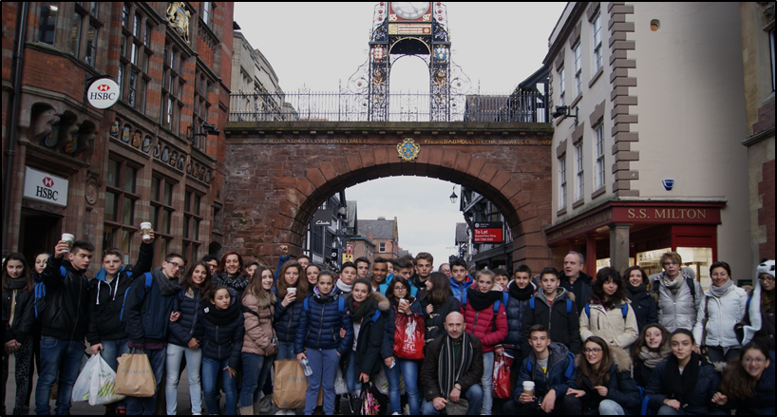

University of Chester - Homestay Accommodation - Factsheet

Available start dates 1st August 2020 – 29th June 2021

Accommodation Homestay – single, double or triple person occupancy

Maximum Students on site Approx 100

Programme Full work experience
Work-related English lessons, seminars & workshops,
Work experience & English lessons
(See Appendix for sample programmes)

Meals 3 meals a day

Nearest Airports Manchester - 35mins
Liverpool - 35mins
East Midlands - 1 hour 40mins
Birmingham - 1 hour 45mins
What’s Included:
        - Full-board host family accommoodation as described
        - 30-40 certifiable of ASL hours per week (programme specific)
        - Initial grading test on arrival (programme specific)
        - Maximum classes of 16 students (programme specific)
        - End-of-course certificate and report from a British Council accredited provider

Bristol

Bristol is one of Britain’s favourite cities and was voted UK’s best place to live in 2017 by The Sunday Times. It has a proud maritime history and it is from here that many of England’s great explorers set off to travel the world. The City is situated in the South West of England with the River Avon on each side.

Top Visitor Attractions From Bristol

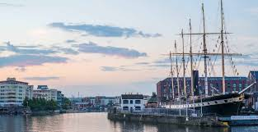
SS Great Britan
SS Great Britain is a museum ship and former passenger steamship, which was advanced for her time. She was the longest passenger ship in the world from 1845 to 1854. She was designed by Isambard Kingdom Brunel, for the Great Western Steamship Company's transatlantic service between Bristol and New York.

Clifton Suspension Bridge
The world famous Clifton Suspension Bridge was designed by the great Victorian engineer Isambard Kingdom Brunel.
Designed in the early 19th century for light horse drawn traffic, it still meets the demands of 21st century commuter with 11-12,000 vehicles crossing it every day.
The Clifton Suspension Bridge’s spectacular setting on the cliffs of the Avon Gorge has made it the defining symbol of Bristol, drawing thousands of visitors a year.

Bristol Zoo Gardens
Opened in 1836 by the Bristol, Clifton and West of England Zoological Society, Bristol Zoo is the world's oldest provincial zoo. It is a Victorian walled zoo located between Clifton Down and Clifton College, near Brunel's Clifton Suspension Bridge; it covers a small area by modern standards, but with a considerable number of species.

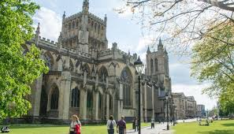
Bristol Cathedral
Bristol Cathedral, formally the Cathedral Church of the Holy and Undivided Trinity, is the Church of England cathedral in the city of Bristol, England. Founded in 1140 and consecrated in 1148, it was originally St Augustine's Abbey but after the Dissolution of the Monasteries it became in 1542 the seat of the newly created Bishop of Bristol and the cathedral of the new Diocese of Bristol. It is a Grade I listed building.

Bristol – Homestay

Location
Bristol is one of Britain’s favourite cities. It has a proud maritime history and it is from here that many of England’s great explorers set off to travel the world. Now a thriving cultural centre and the country’s 11th biggest city in 2017 Bristol topped the Sunday Times rankings of best places to live in Britain and was listed 4th in the Rough Guide’s top ten cities to visit worldwide.

Accommodation
Homestay

All of our host families are located in beautiful parts of the city. We offer single, twin and triple rooms with our accommodating and friendly families who all possess full DBS checks and are of the highest standard.

The families in Bristol are all in the very leafy suburbs of the city within easy access to the city centre itself. All families offer a drop off and pick up service in Bristol everyday for no extra cost. This makes Bristol a fantastic place for slightly younger groups who would like to travel to the UK

UKLC have very structured and strict policies and procedures that ensure that the students’ safety and wellbeing is paramount. UKLC will also provide a Homestay Co-Ordinator whose role it is to liaise with host families to ensure that students are safe at all times.

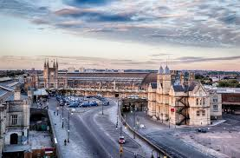

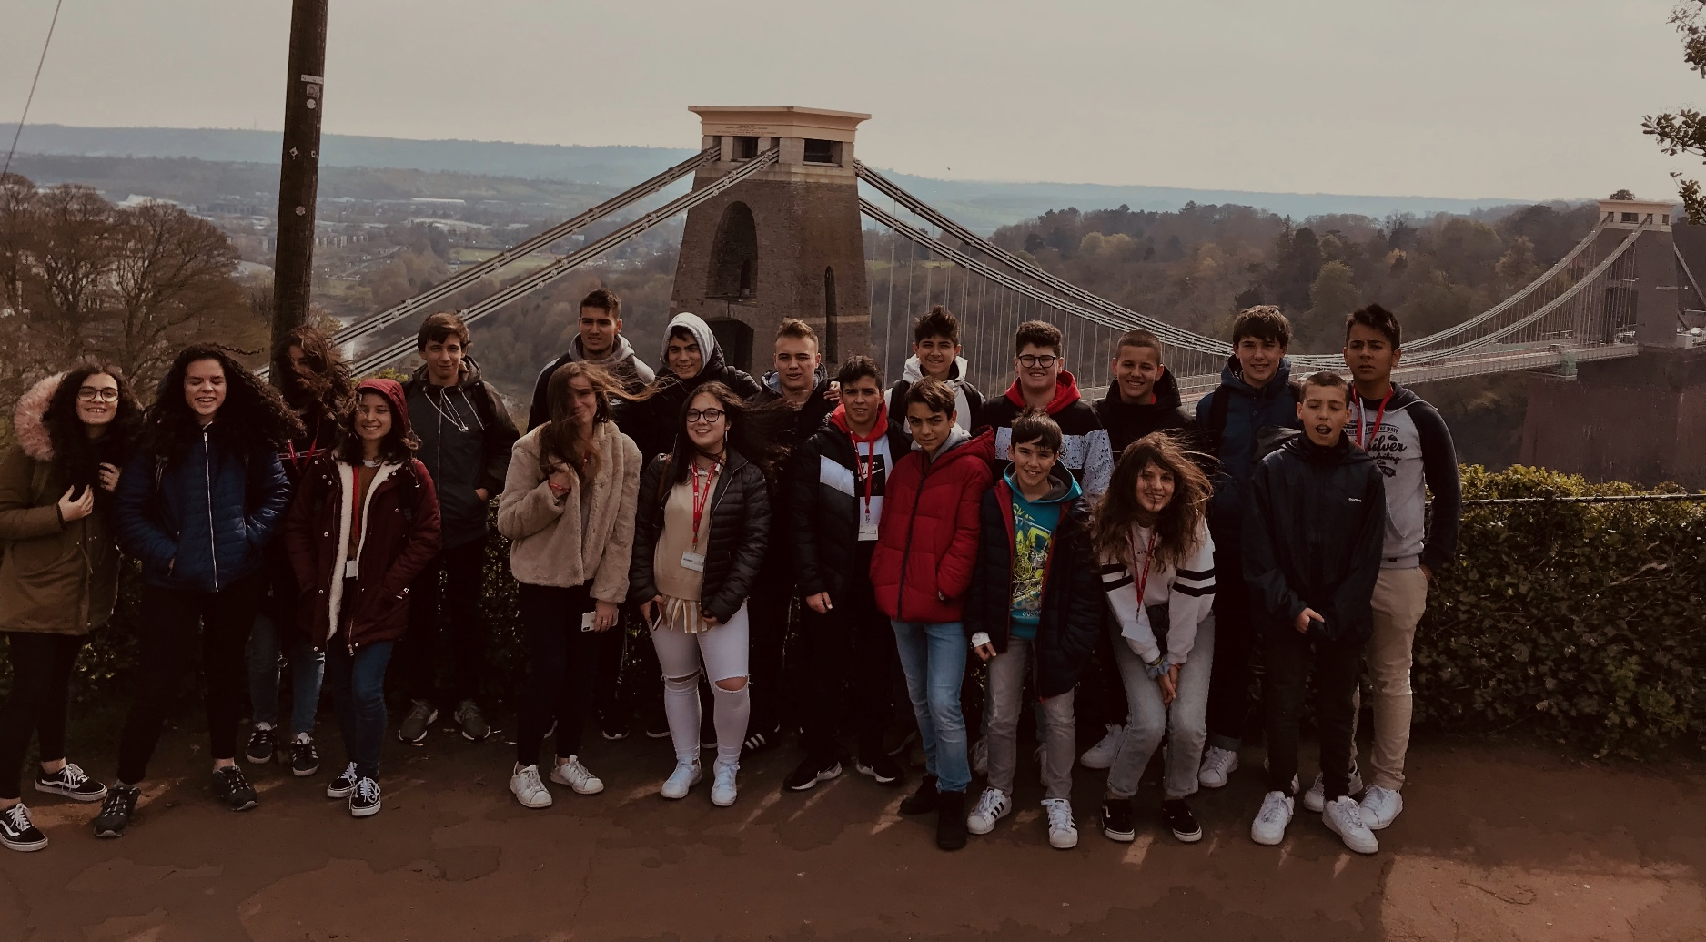
Bristol - Homestay - Factsheet

Available start dates 1st August 2020 – 29th June 2021

Accommodation Homestay – single, double or triple person occupancy

Maximum Students on site Depends on time of booking

Programmes Mini Stay, Late Summer Options, Easter Camps, PON
(See Appendix 1 for sample 6 night programme)

Meals 3 meals a day taken including packed lunch

Nearest Airports Bristol - 25mins
Birmingham - 1 hour 45mins
London Heathrow - 2 hours
What’s Included:
        - Full-board host family accommoodation as described
        - 30-40 certifiable of ASL hours per week (programme specific)
        - Initial grading test on arrival (programme specific)
        - Maximum classes of 16 students (programme specific)
        - End-of-course certificate and report from a British Council accredited provider

Available ASL Programmes

Full Work Experience

UKLC are pleased to offer students a unique opportunity to gain invaluable experience in working within a British organisation in the beautiful city of Chester. Students will be placed in one of a number of different business sectors across the city including hospitality, retail, small businesses and charity organisations. By partaking in this programme students will complete a minimum of 40 hours of work experience per week. UKLC will be on hand to offer support to all the students during their stay ensuring that the students receive the maximum benefit from their stay with us.

Capacity = 30 students
For a sample programme please see Appendix 1

Work-Related English Lessons, Seminars & Workshops

UKLC have delivered a large number of these programmes since 2014 in a number of different subject areas including science, geography, business studies & aeronautics.

During this programme students will combine subject-specific English lessons, workshops, seminars & company visits. All of which are designed to enhance the employability of the students. UKLC have a proven track record of delivering a variety of unique ASL programmes carefully designed to meet each groups’ needs. The benefit of this programme is to give students a better understanding of what to expect in a working environment in the UK.

Topics covered can include; CV Writing; Interview Skills & Practice ; Goal Setting; Presentation Skills; Public Speaking Workshops; Employability; Market Research

Capacity = 100 students
For a sample programme please see Appendix 2

Work-Related English Lessons, Seminars, Workshops
& Work Experience

This programme is a minimum of two weeks long. It has been designed to give students a better understanding of what is expected of them before entering a workplace in the UK.

Week 1
Students will complete 30 hours of certifiable English tuition in the mornings with afternoon workshops and seminars to prepare them for their work placements. Seminars can include; work place scenarios, dealing with customers & expectations of the job.

Week 2
Students will be placed in their specific work placements where they will put into practice the skills they have learnt in the preceeding week.

Capacity = 60 students
For a sample programme please see Appendix 3
UKLC ASL Pricing Schedule 2020-21
 | Centres | Dates | Programmes | 15-29 Students | 30+ Students
 | Chester Homestay | 1st August 2020 – 29th June 2021 | 6 Night - Full Work Experience | £369 | NA
 |  |  | 14 Night – Full Work Experience | £861 | NA
 |  |  | 6 Night – Business English, Seminars & Workshops | £392 | £388
 |  |  | 14 Night  Pricing Schedule (Net)  August 2020 – June 2021  - 7 Night - Business English, Seminars & Workshops  - 7 Night – Full Work Experience | £895 | £865
 | University of Chester - Residence | 1st August 2020 – 29th June 2021 | 6 Night - Full Work Experience | £385 | NA
 |  |  | 14 Night – Full Work Experience | £898 | NA
 |  |  | 6 Night – Business English, Seminars & Workshops | £425 | £420
 |  |  | 14 Night  - 7 Night - Business English, Seminars & Workshops  - 7 Night – Full Work Experience | £925 | £915
 | Bristol Homestay | 1st August 2020 – 29th June 2021 | 6 Night - Full Work Experience | £372 | NA
 |  |  | 14 Night – Full Work Experience | £868 | NA
 |  |  | 6 Night – Business English, Seminars & Workshops | £382 | £379
 |  |  | 14 Night  - 7 Night - Business English, Seminars & Workshops  - 7 Night – Full Work Experience | £922 | £909
Included in Programme:
• Full board and accommodation • English tuition • Transport and entry for excursions
• Free Group Leader Places*

* A free Group Leader place is provided for every 15 students. Additional group leaders will cost £210 for a 6 night stay & £490 for a 14 night stay.
* Additional length of stays and programme are available upon request.
* Transfers to and from airports to the centre are not included in the price.
University of Chester Homestay - Supplements

 | Dietary Requirements | Cost Per Student Per Night
 | Coeliac | £4
 | Nut | £4
 | Vegan | £4
 | Halal | £4
 | Homestay Requests
 | Single Room Supplement | £4
 | Single Student in One Homestay | £4
 | Transport
 | Bus Pass | £7 per week
 | Early Arrival/Departure Charge* | £5 per student

*UKLC can accept group arrivals/departures between the hours of 07:00-23:00 hours. There will be an additional charge for flight arrivals between 21:00-23:00 and departures before 09:00.

Appendix 1

Full Work Experience Programme
DATE | ACTIVITY
 | 09:00 – 17:00
Sunday | Arrive, Orientation and Briefing
Monday | Full Work Experience Placement
Tuesday | Full Work Experience Placement
Wednesday | Full Work Experience Placement
Thursday | Full Work Experience Placement
Friday | Full Work Experience Placement
Saturday | Manchester with MOSI
Sunday | Free Day/Optional Excursion
Monday | Full Work Experience Placement
Tuesday | Full Work Experience Placement
Wednesday | Full Work Experience Placement
Thursday | Full Work Experience Placement
Friday | Full Work Experience Placement
Saturday | Liverpool with The World Museum
Sunday | Depart

*For a 6 night programme please consider the first 6 days of the standard programme above

Appendix 2

Work-Related English Lessons, Seminars & Workshops
DATE | ACTIVITY
 | 09:00 – 12:30 | 14:00 – 17:30
Sunday | Arrive, Orientation and Briefing
Monday | Business-Specific English Lessons | CV Writing, Cover Letter Workshop
Tuesday | Business-Specific English Lessons | Project Work – Investigating Local Travel Trends (Market Research)
Wednesday | Business-Specific English Lessons | Seminar With Local Business
Thursday | Business-Specific English Lessons | Visit to Local Business
Friday | Business-Specific English Lessons | Project Presentation
Saturday | Manchester with MOSI
Sunday | Free Day/Optional Excursion
Monday | Business-Specific English Lessons | Employability Workshop
Tuesday | Business-Specific English Lessons | Mock Interview Scenarios
Wednesday | Business-Specific English Lessons | Seminar With Local Business
Thursday | Business-Specific English Lessons | Visit to Local Business
Friday | Business-Specific English Lessons | Public Speaking Workshop
Saturday | Liverpool with The World Museum
Sunday | Depart

*English lesson subjects are flexible and based on the groups request
Appendix 3

Work-Related English Lessons, Seminars, Workshops & Work Experience
DATE | ACTIVITY
 | 09:00 – 12:30 | 14:00 – 17:30
Sunday | Arrive, Orientation and Briefing
Monday | Business-Specific English Lessons | CV Writing, Cover Letter Workshop
Tuesday | Business-Specific English Lessons | Project Work – Investigating Local Travel Trends (Market Research)
Wednesday | Business-Specific English Lessons | Seminar With Local Business
Thursday | Business-Specific English Lessons | Visit to Local Business
Friday | Business-Specific English Lessons | Project Presentation & Mock Interview Scenarios
Saturday | Manchester with MOSI
Sunday | Free Day/Optional Excursion
Monday | Full Work Experience Placement
Tuesday | Full Work Experience Placement
Wednesday | Full Work Experience Placement
Thursday | Full Work Experience Placement
Friday | Full Work Experience Placement
Saturday | Liverpool with The World Museum
Sunday | Depart

